RESERVATION FOR THE CONGRESS T-SHIRTS

Congress t-shirts are available in two different drawing herp subjects (Pelobates fuscus and Podarcis muralis, by Dr. Stefano Scali), and two different colour (black or grey). Will be available in size: S, M, L, XL and XXL*. To request one (or more), please fill the form and send to seh-congress@unipv.it. T-shirts will be provided on a voluntary contribution starting from €20 each.
PERSONAL DATA
Name
Surname
email

 |  | Number
Pelobates fuscus
Size: | S
 | M
 | L
 | XL
 | XXL
Podarcis muralis
Size: | S
 | M
 | L
 | XL
 | XXL
 | TOTAL

Pelobates fuscus
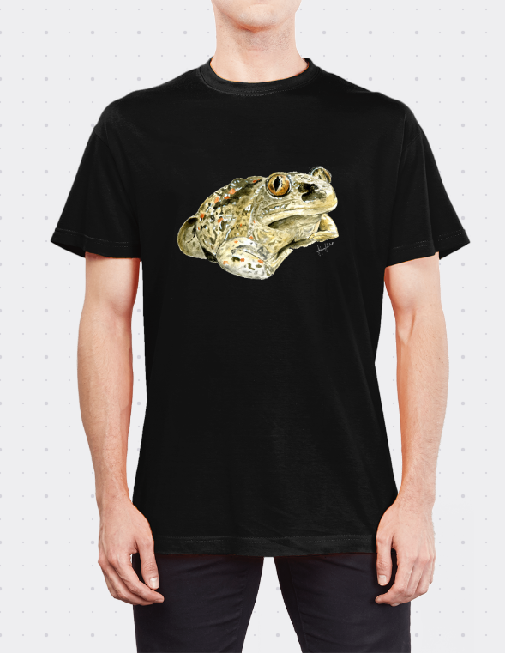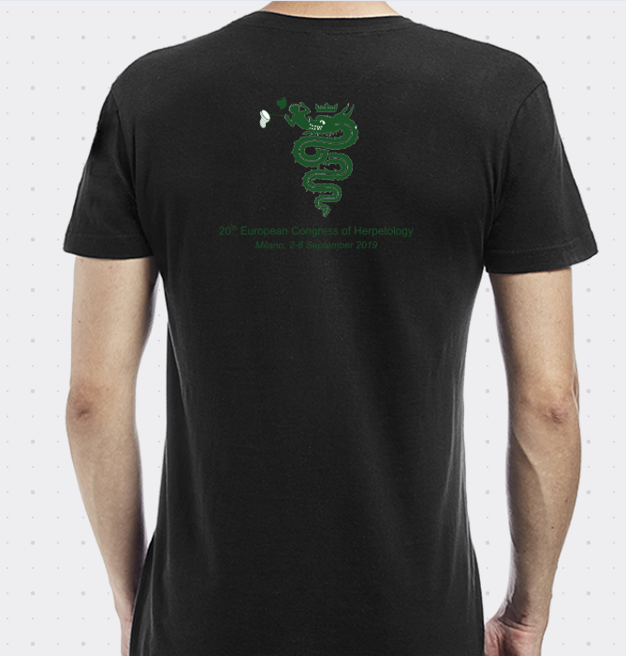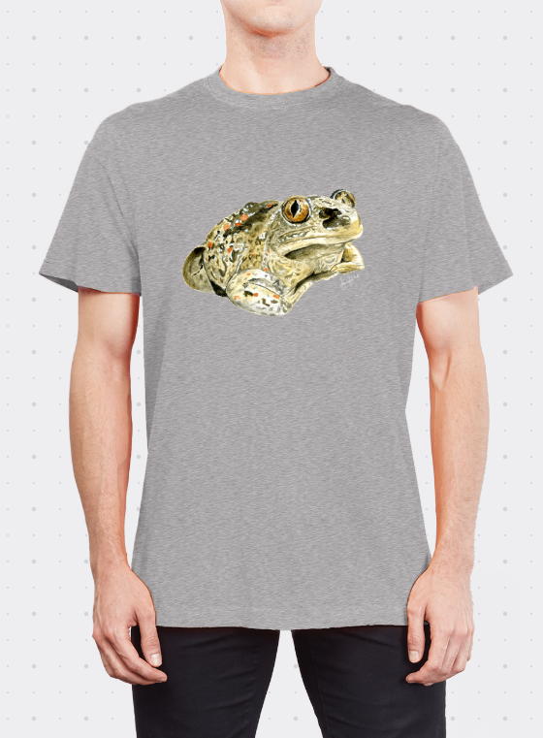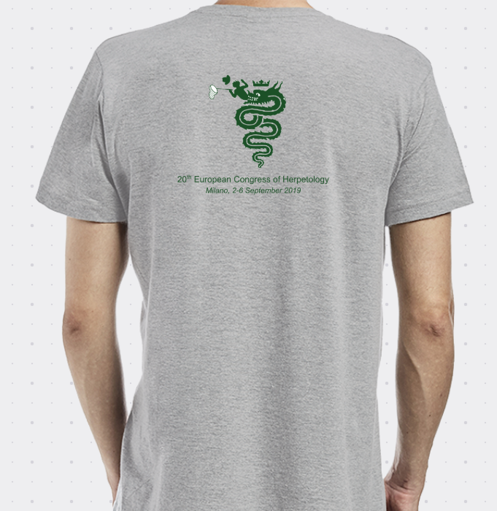

Podarcis muralis
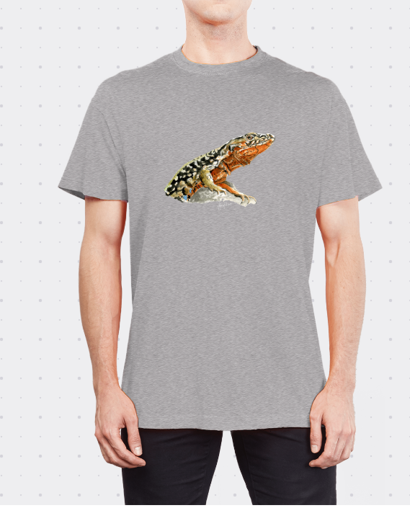
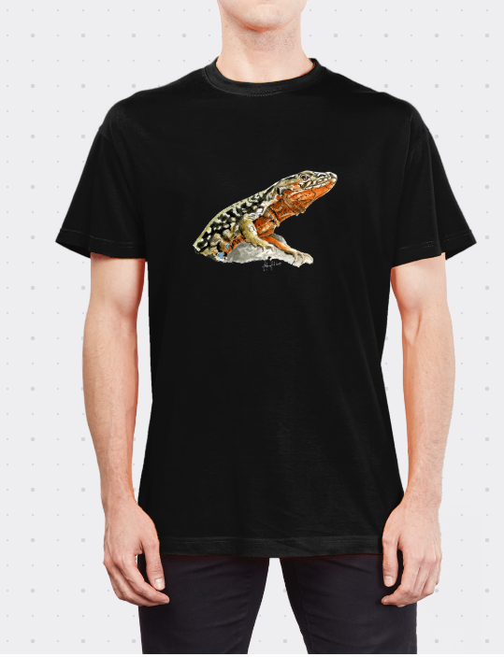
* size conversion table
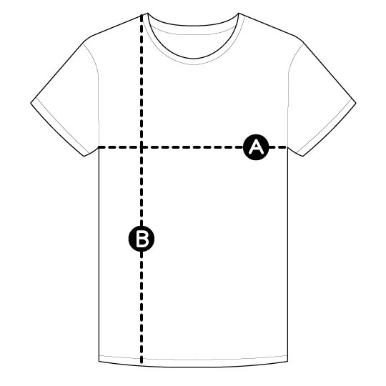

 | A | B
S | 50 cm | 70 cm
M | 53 cm | 72 cm
L | 56 cm | 74 cm
XL | 58 cm | 76 cm
XXL | 62 cm | 78 cm

